We need to talk about suicide: helping everyone to feel more confident to talk about suicide

Briefing 1
We need to talk about suicide: helping everyone to feel more confident to talk about suicide is an eLearning programme that has been developed for the wider public health workforce including voluntary sector, blue light services, prison staff and prison listeners health and social care. It was developed by a range of experts including experts by experience i.e. those people who have attempted to take their own lives and those bereaved and affected by suicide.
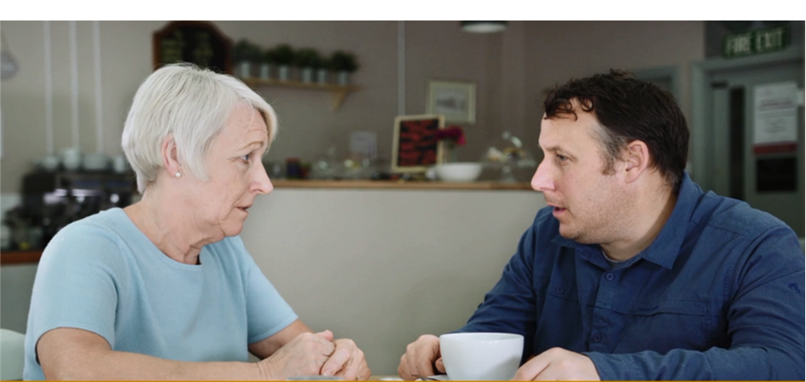
Two-thirds of people who take their own lives are not known to mental health services. Almost everyone thinking about suicide doesn’t want to stop living they just want to stop the pain and distress they are feeling. Talking about suicide does not make someone more likely to take their own lives. Another person showing compassion and care can only make things better not worse.
The purpose of the programme is to support the ambition of reducing the stigma associated with suicide, to help everyone see that simply asking someone how they are and talking about suicide can really help. The programme supports learning and development in suicide competence at level one.

The programme is based on four storylines of people who are at increased risk of dying by suicide. During these four 4 video scenarios the learner will have the opportunity to reflect on their learning. The learner will be able to complete the entire programme at once or complete at their own pace in smaller sections.
There is no formal assessment but the learner is encouraged to stop and reflect on the learning as they progress through the course and can print out a certificate on completion of the course as evidence of professional development. The programme takes approximately between 60-90 minutes to complete.
How might the programme be used?
- As an introduction to suicide awareness and suicide prevention skills
- To consolidate existing skills on suicide prevention
- As part of an organisation’s induction process, reflecting a commitment to reducing death by suicide
- For personal and professional development

Proposed target audience
- Non-mental health practitioners
- Anyone working with the public across a wide range of settings
- Anyone in a volunteering role with contact with the public
- Administrative and support staff in health and care across a range of settings such as primary care, acute and supported living settings
- Administrative and support staff in other public sector settings such as local authorities and the voluntary sector
- Public health/health promotion staff across all sectors including local authorities, NHS and primary care

The learning is specifically aimed at making sure that everyone in contact with the public, in whatever role, knows how to spot any signs of mental distress and feel comfortable in talking about suicide.
Talking about suicide can be used as a normal part of all our interactions at home, in the workplace and in the wider community.

How can I access We need to talk about suicide: helping everyone to feel more confident to talk about suicide?
There are several ways to access We Need to Talk about Suicide: helping everyone to feel more confident to talk about suicide
- Access via e-Learning for Healthcare (e-LfH) on the e-LfH Hub:
If you log-in to your account or register for an account on the e-LfH Hub, a record of your learning and activity in the package will be saved. If you don’t have an account you can still play the package but no record of your achievement will be saved.
portal.e-lfh.org.uk/Component/Details/544927
- Access via the Electronic Staff Record (ESR):
If you are from an NHS Trust who deliver their eLearning through ESR, you can access the package through the ESR NLMS portal. When you log-in to ESR you will need to enrol on to the package from the Learner Homepage. You can do this by searching for the following course title:
000 Suicide Prevention - We need to talk about Suicide.
Further information about how to navigate the ESR Learner Homepage can be found via the following link:
www.esrsupport.co.uk/nlms/eLearningHelp.html#learnerhomepage
More details about the package are also captured in the ESR eLearning Catalogue:
www.esrsupport.co.uk/catalogue.php5?m=showCourse&ID=71881
- HTML Version - Open Access:
The package can be played via the following link which can also be inserted into your local webpage/website. Please note though, this version of the package will not save your progress or track your learning activity:
www.nwyhelearning.nhs.uk/elearning/HEE/SuicidePrevention/index.html
- SCORM Version:
You can access the SCORM files of the package to upload and play within your own Learning Management System (LMS). Please note, there is a Flash version and a HTML version of the SCORM files. Depending on your LMS requirements and browser preference, please request which version you would like. To help manage version control, you will need to complete the following online request form:
survey.yas.nhs.uk/s/SuicidePrevention/
If you need to raise any support queries about the package,
please contact the e-LfH helpdesk: support@e-lfh.org.uk

Additional note re usage data on the e-LfH Hub:
If your organisation is accessing the package through the e-LfH Hub and you would like to access usage data for your staff, you must ensure the following: -
- An appropriate lead in the organisation (e.g. HR lead) with the authority to access the data should make the request to the e-LfH helpdesk:
support@e-lfh.org.uk

- The appropriate person would need to have set up a login on the e-LfH Hub in order to be able to access and run compliance reports.

- The organisation must ensure that the eLearning accounts for their staff on the e-LfH Hub are set up using their work email address, e.g. if Cheshire East Council want to view the usage data for their staff, then they should ensure all staff are registered with their @cheshireeast.gov.uk email address.

If you would like further information about this briefing, please contact:
Phpn.north@hee.nhs.uk

