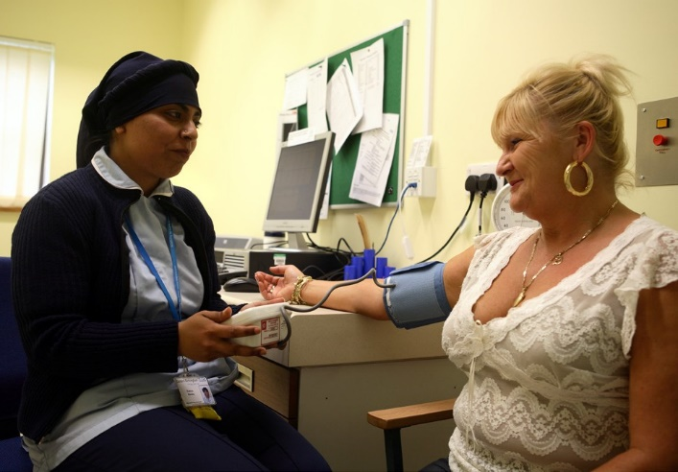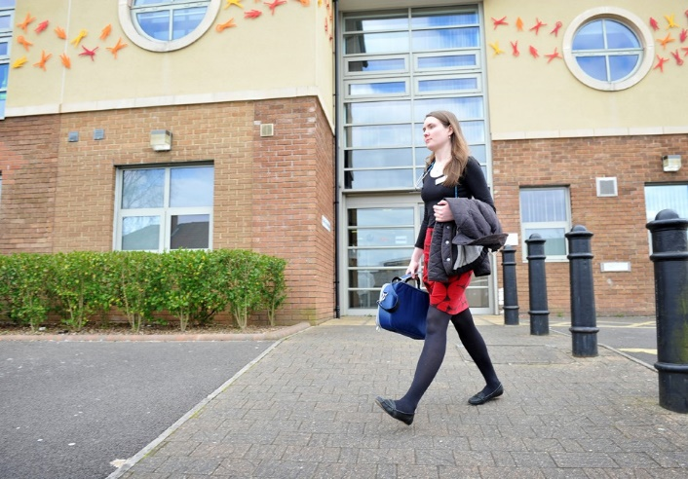

**Introducing General Practice Assistants**

Information for patients and relatives

**How could a General Practice Assistant help me?**

A General Practice Assistant may help you to prepare for your GP appointment by speaking to you beforehand, taking some details or doing some basic tests. They may also be present during your appointment, to help the GP with any examination or treatment you might need. Finally, after your appointment they may arrange a referral or follow up appointment for you and help to explain any treatments or procedures. GP Assistants can support you in a number of ways but this will depend on your circumstances and the type of support you need.

**What training do General Practice Assistants need?**

General Practice Assistants typically undertake at least six months of ‘on the job’ training which leads to the award of a certificate. They are trained and supervised by the practice team and their learning is

assessed by a qualified GP. To complete their learning, General Practice Assistants must demonstrate their skills in five key areas, including basic clinical duties, administration, communication and record keeping.

**Where can I find out more information?**

To find out more about General Practice Assistants, please speak to a member of the practice team at your surgery.

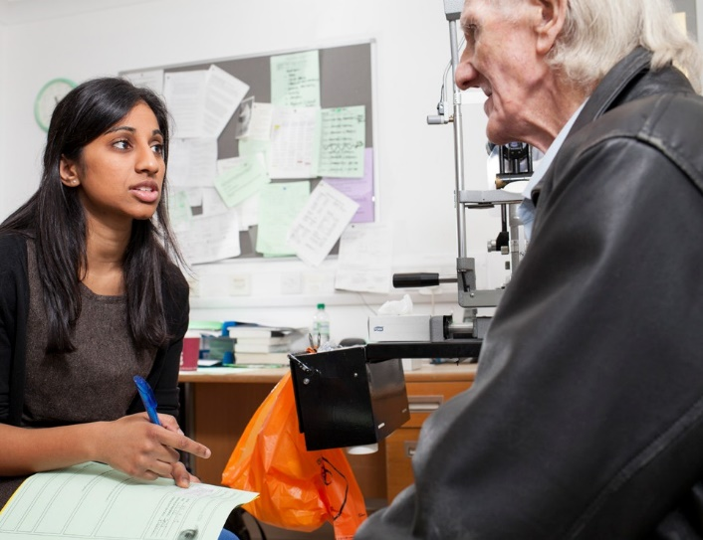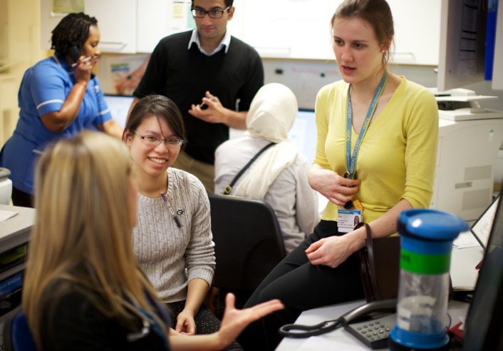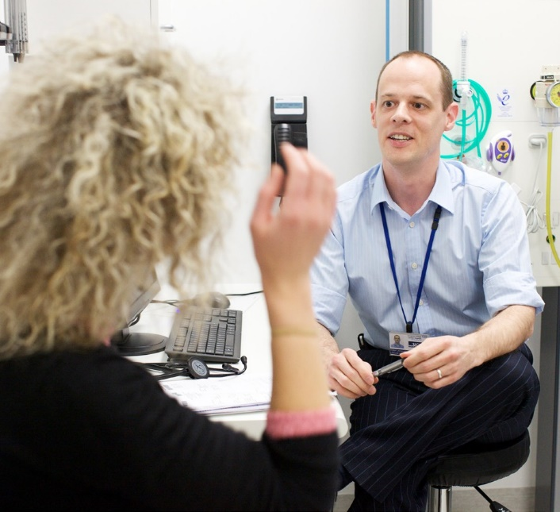

**Introduction**

This leaflet provides information for patients and relatives about a new role that is

being introduced at some General Practice surgeries. It explains who General Practice Assistants are, what they do and how they work as part of the practice team.

**How do General Practice Assistants work as part of the practice team?**

General Practice Assistants work as part of a practice team that includes doctors (GPs) and nurses, whose workload is often increased

by administrative tasks such as emails. Some of these routine tasks don’t necessarily need to be completed by a doctor or nurse. By relieving some of this administrative burden, General Practice Assistants can help highly qualified colleagues to make best use of

their time, allowing them to focus on caring for patients. By supporting GPs with some basic clinical duties, they can also help with the smooth running of appointments during surgery hours.

**Who are General Practice Assistants?**

The General Practice Assistant is a new role in the practice team. They support GPs in the smooth running of the surgery by handling routine administrative tasks and some basic clinical duties, helping to free up

the GP’s time. They work with the direction of a GP, who has overall responsibility for your medical care.

**What do General Practice Assistants do?**

General Practice Assistants can carry out a range of tasks that contribute to the care of patients, including:

•

Routine administrative tasks such as arranging follow up appointments, managing post / emails, completing paperwork for the GP to approve and sign and helping the GP to liaise with other organisations.

Basic clinical duties such as:

* Preparing patients for their GP appointment by taking details, checking blood pressure, dipstick urine testing
* Helping the GP with some clinical tasks
* Explaining treatments, procedures and follow up arrangements to patients
* Explaining healthy lifestyle choices

•