Bulk Uploads
Log in with your admin username and password
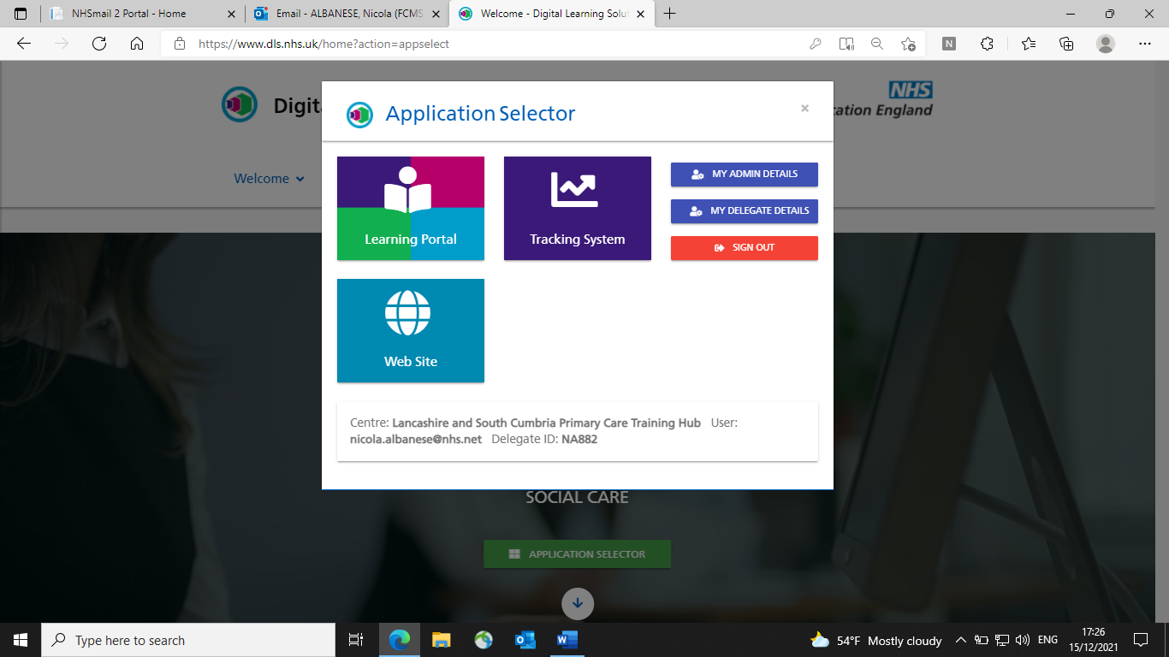
Select Tracking System

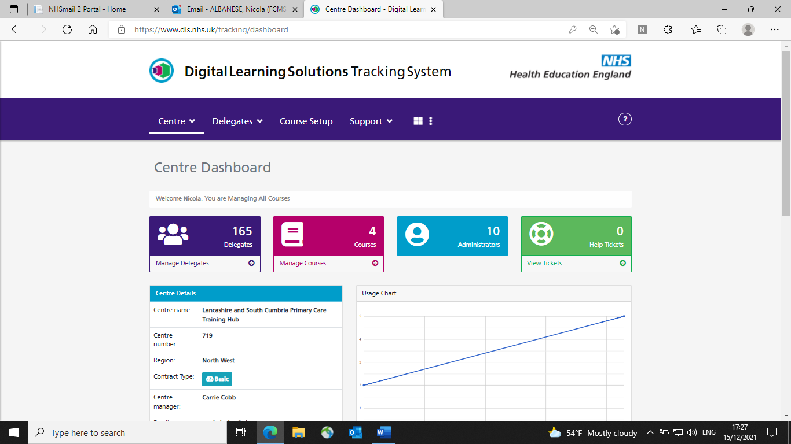
Select Manage Delegates

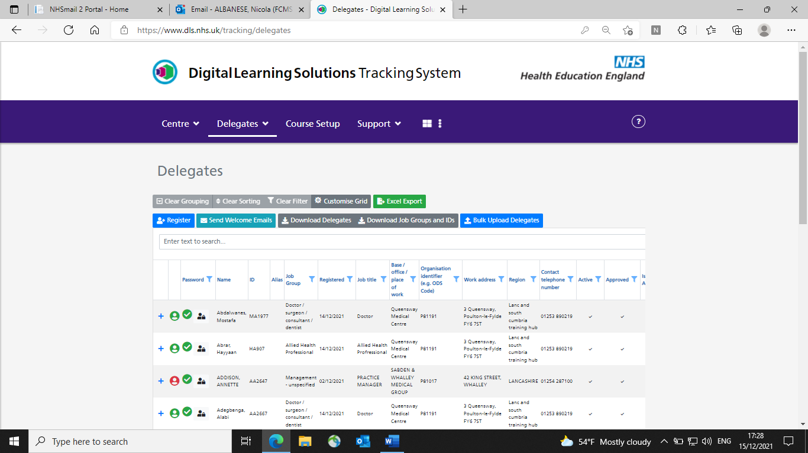

Select Bulk Upload Delegates

Ensure the “send welcome email” is ticked (it is by default but just in case)
You can also select when the welcome letter will be sent by changing the date- I keep this as today’s date

Select the file you want to upload
And then press “upload and process

Use the template Andrea sent to upload your delegates- if you need an explanation of this please see later pages

When you upload, any errors will be highlighted, and these can be amended

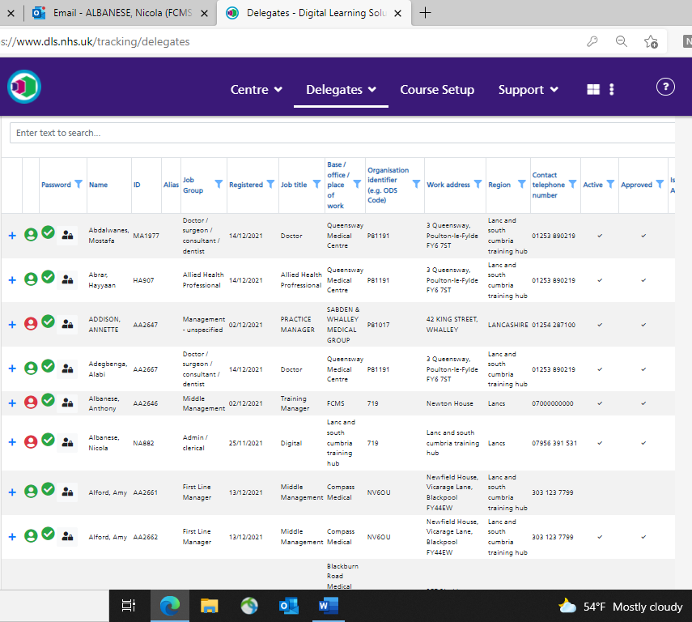
Your delegates will then show in the delegate list as above
I then set a password for each candidate

Candidates you have just uploaded will appear like this (red circle)

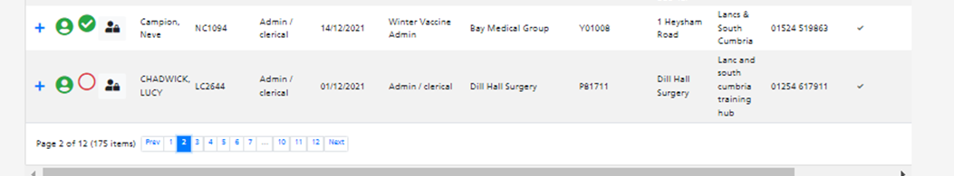
Click on this symbol

I then set a password such as Password1! (passwords must have numbers and a symbol)
Press Set

This screen confirms the pass work has been set

I then go through all my newly uploaded delegates to complete this process

A confirmation email is then sent to your delegates

I email them all explaining that I have set their password to Password1! and advise them to change this when they log on

Any queries please let me know Nicola.albanese@nhs.net

Spreadsheet used to upload bulk delegates
Open the spreadsheet Andrea sent across

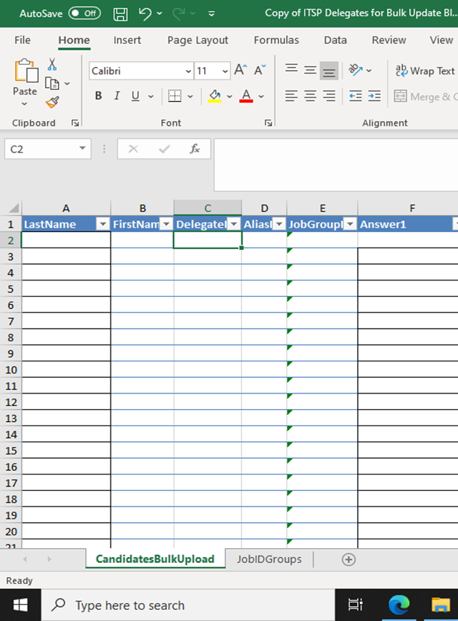

Complete Last name and First Name in A and B respectively
Leave columns C and D blank

For column E- the job ID groups are in the second tab
Select the appropriate job title from the drop down menu

Columns G, H and I are to input the surgery name, P code or ODS and Address

In column J input “Lanc and South Cumbria Training Hub”

In Column K input the telephone number of the surgery
In column L and M type TRUE and TRUE

Finally in column N input individual staff emails

Save the document as the practice name for ease of uploading

Hope this helps

