How to register on the portal

Please click on this link

Welcome - Digital Learning Solutions (dls.nhs.uk)

Welcome - Digital Learning Solutions
Digital Learning Solutions (DLS) home page, Information about products and services, learning content, the DLS team, customer stories, news and contact information
www.dls.nhs.uk

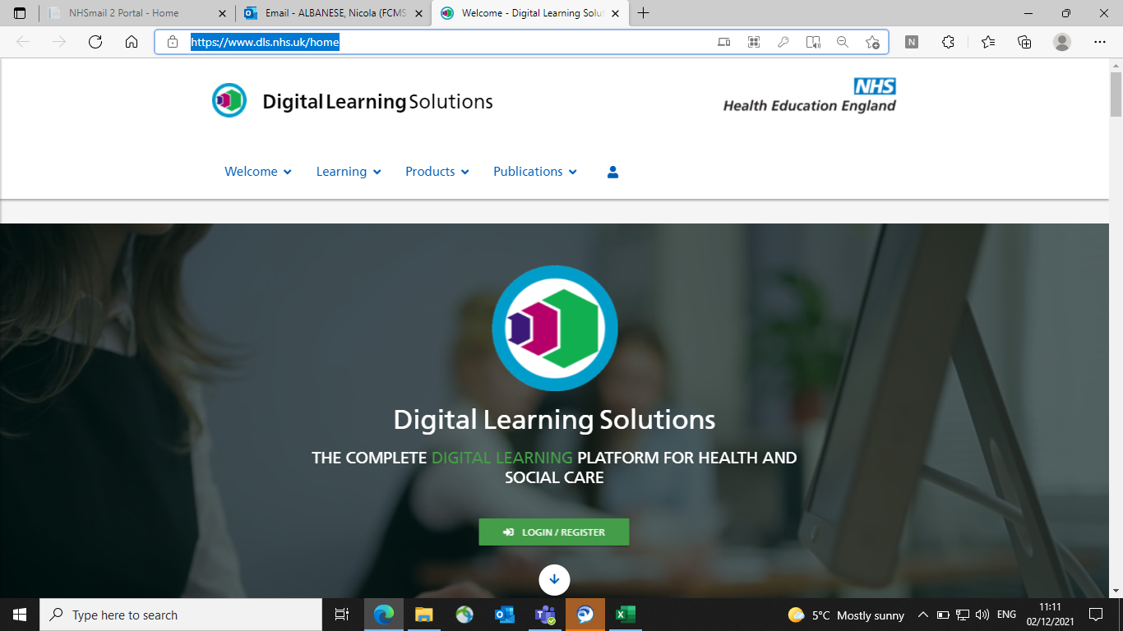

Please click Login/Register- green button as shown above

Click register as shown below

​

The following screen is shown
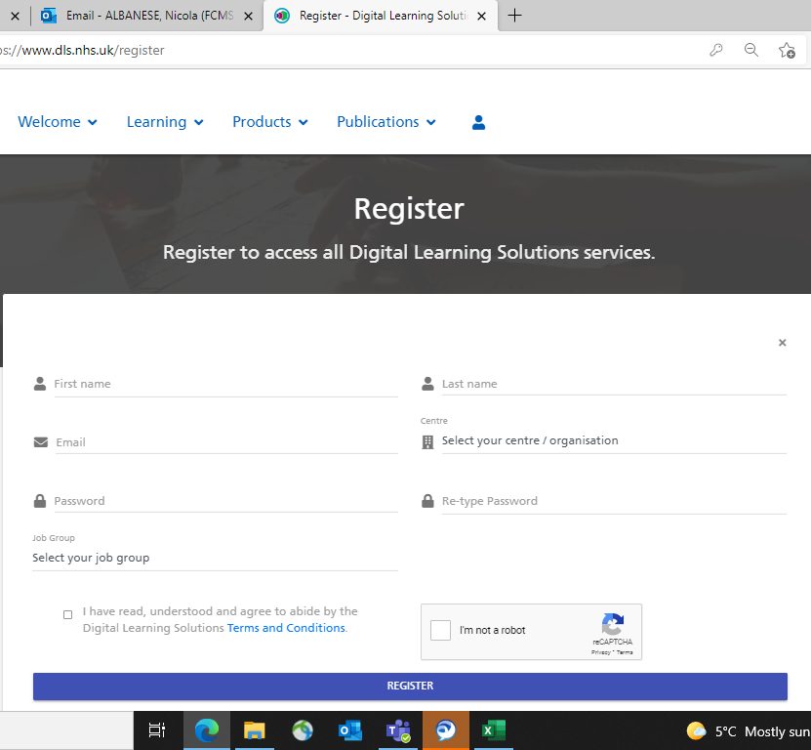

Please insert
- First name
- Last name
- Email
- Select your centre- Please insert here Lancashire and South Cumbria Learning Hub
- ​Create a password- this must contain uppercase letter, number and symbol
- Select job group for example Nurse or Admin etc

Agree to t's and c's
Confirm you are not a robot

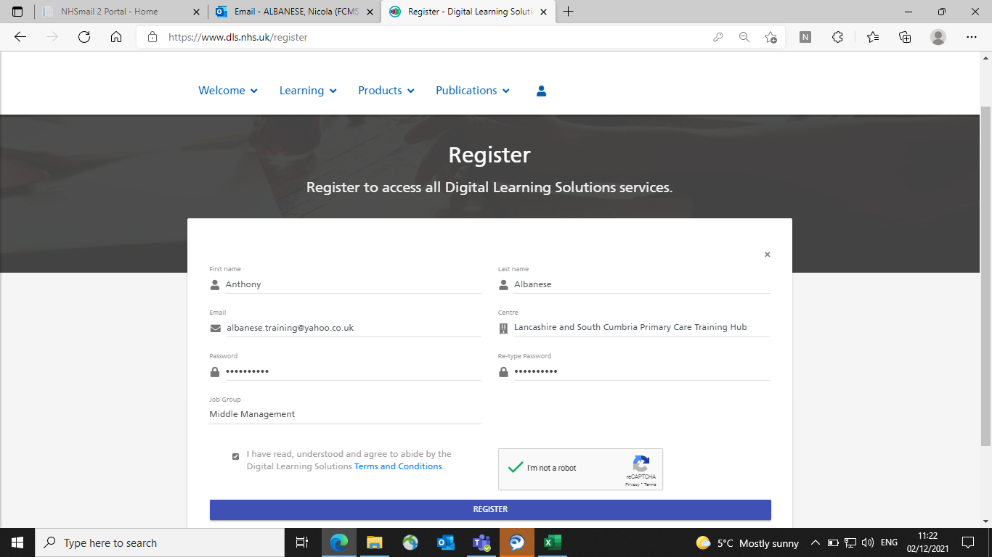

Click register

You may immediately receive a registration number however this may appear

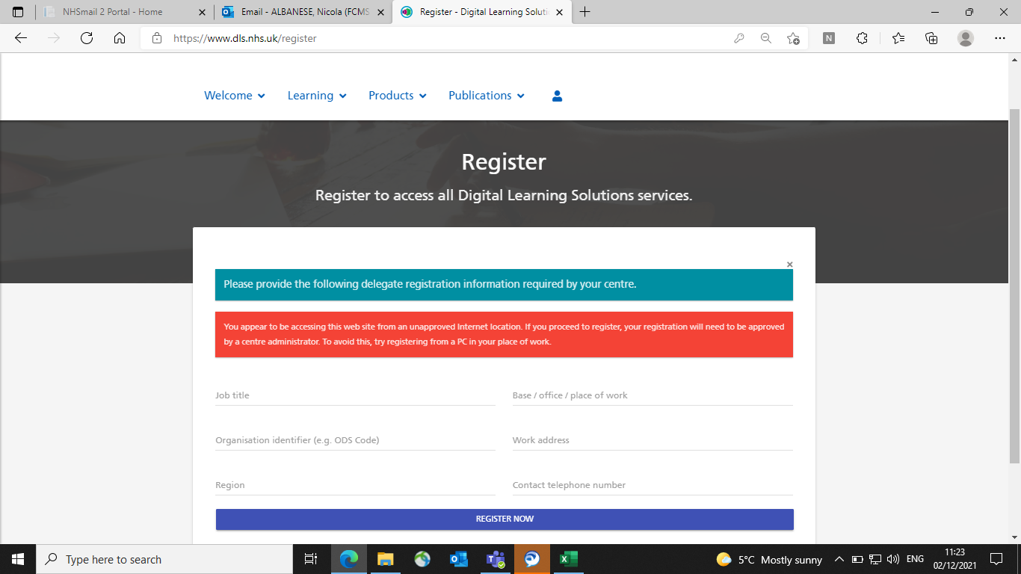

If this is the case please complete your

- Job Title
- Place of work
- Organisational ODS code
- Work Address
- Region
- Contact telephone number
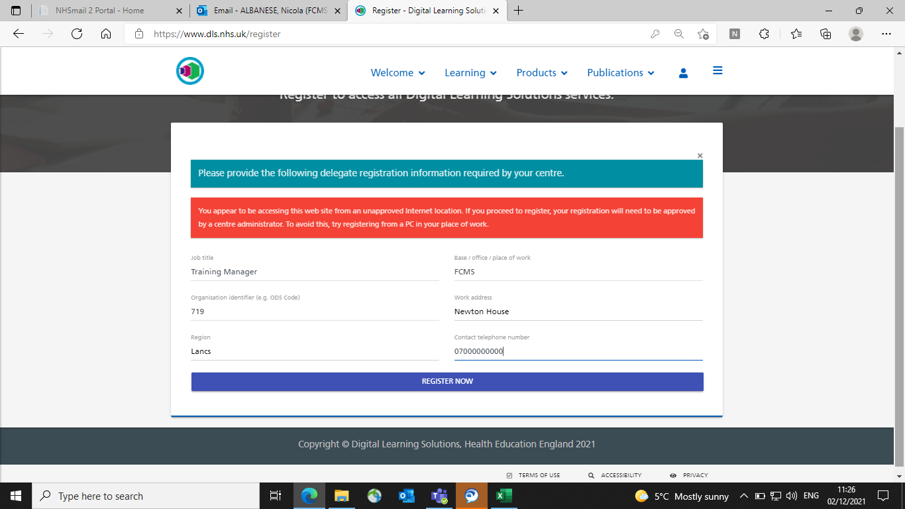

Click Register Now

A delegate number then appears on the screen- this will be unique to you

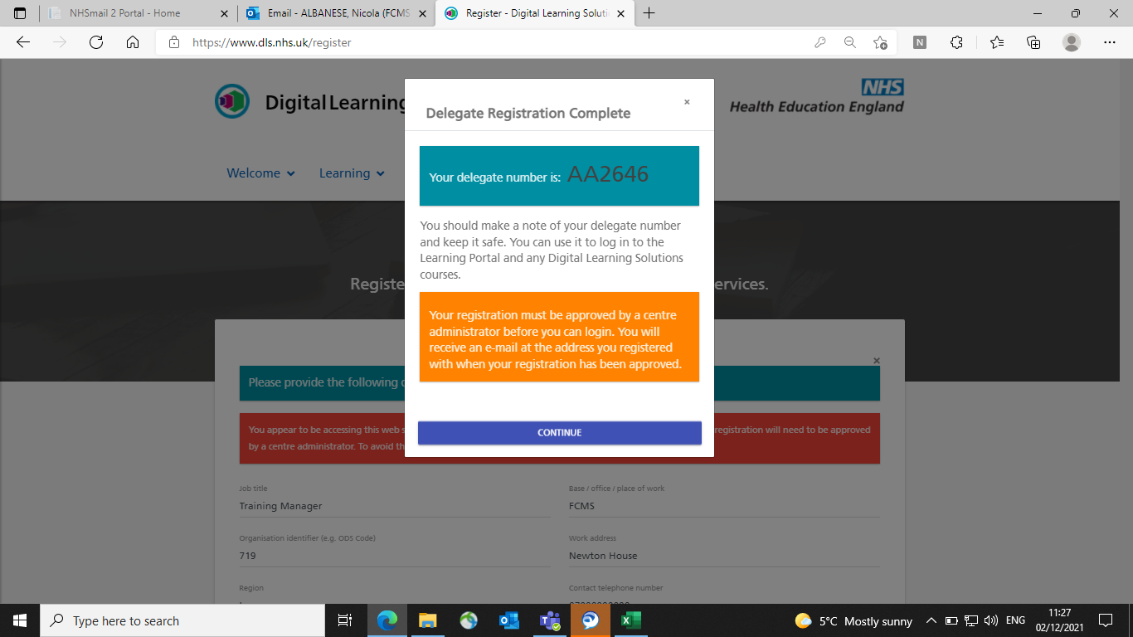

One of the digital team will then approve your registration and you will receive a welcome email.

Please keep a note of the password you created earlier.

When you receive your user ID please log in using this and your password

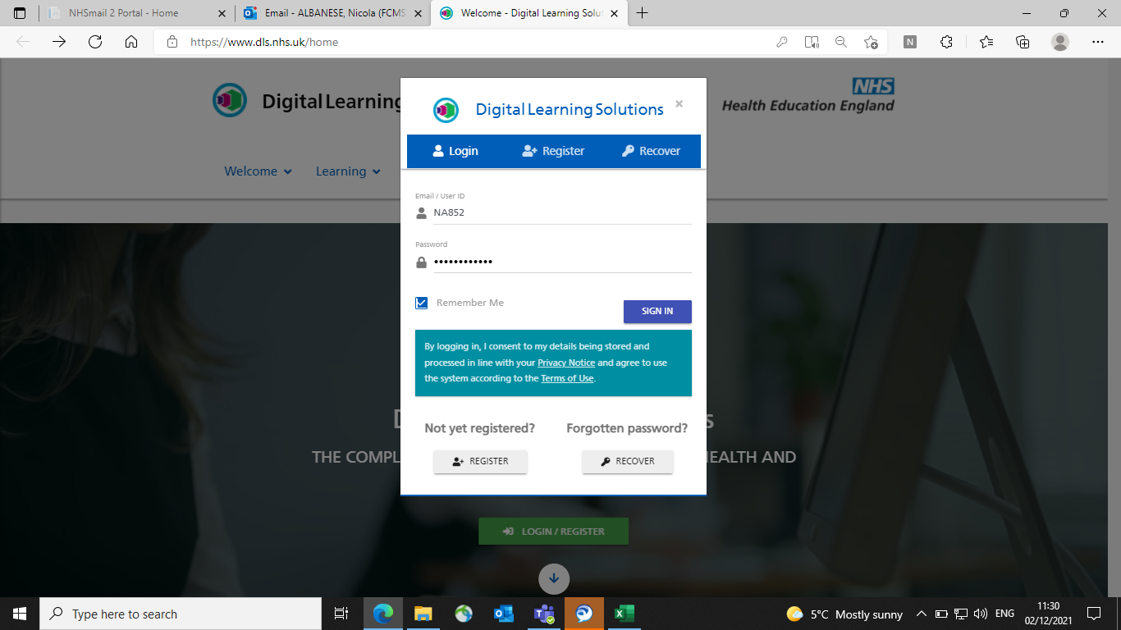

and click Sign in

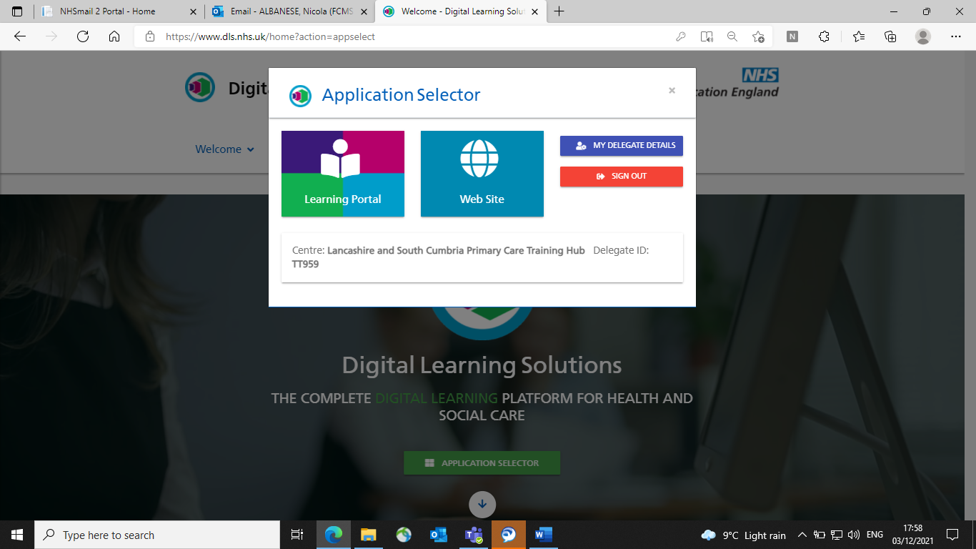

Click on Learning Portal

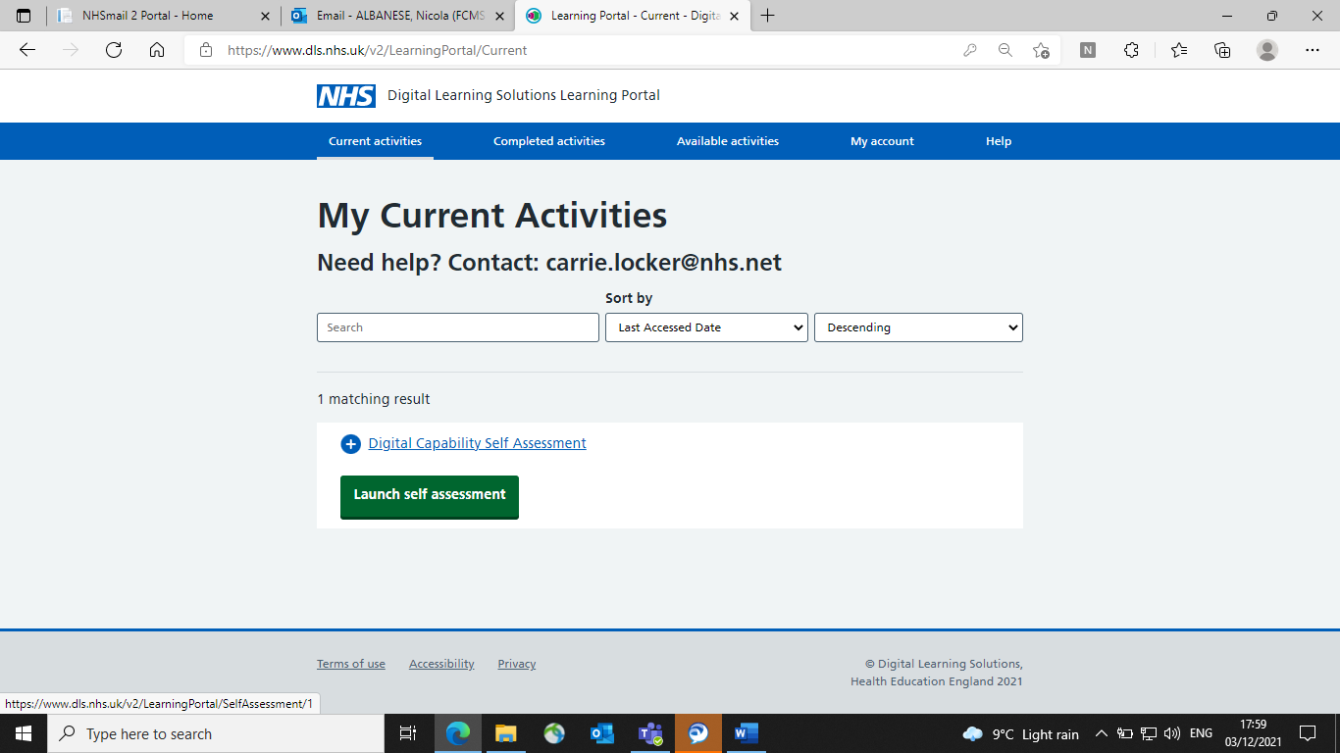

Click on Launch Self Assessment

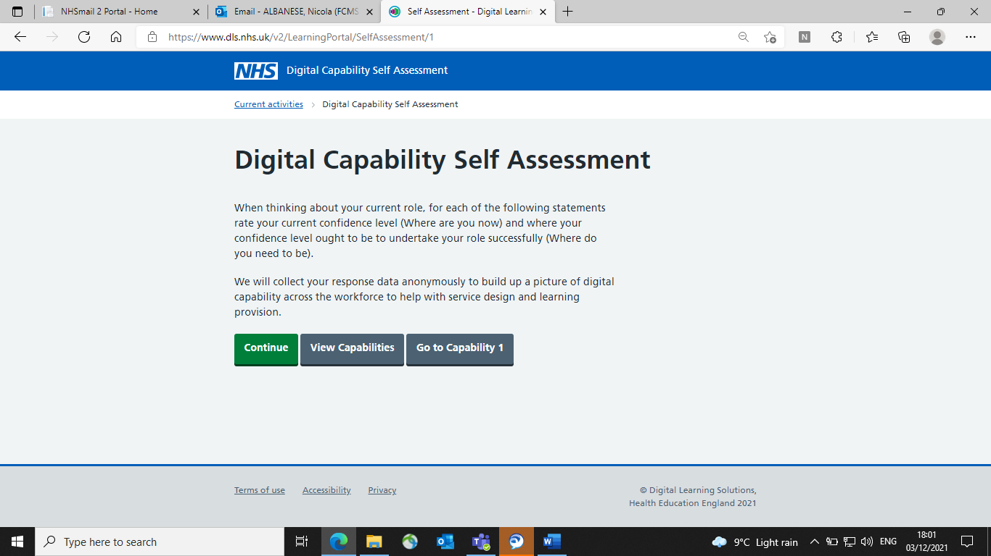

Click continue

Complete the digital tool

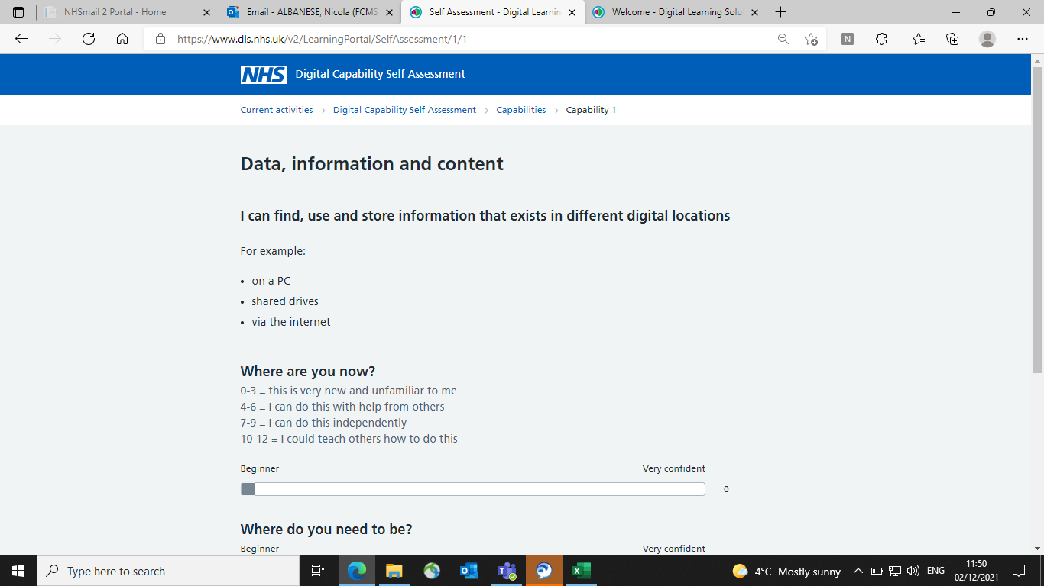

Score the questions 1-12 using the sliding scale and the key 0-12

Once complete, any skills gaps will be identified and training modules which would be most suitable to your needs will be displayed

