Good news story.
Currently, across Lancashire and South Cumbria there are 30 Associate Psychological Practitioners (APPs) or Trainee Associate Psychological Practitioners (TAPPs) working across 29 PCNs. They are working hard to provide a mental health prevention and promotion service in General Practice settings and this hard work and workforce initiative is being recognised. Recently, they have won one award and been nominated for two others.
All PCNs who have had, or are currently working with a T/APP may wish to promote their involvement in these successes and are free to use the banners contained below across their own social media/ newsletters and emails.
1. Winner 2022. The Ruth Young Award for Research Implementation. North West Coast Research and Innovation Awards 2022. ‘Collaborating with General Practice and Community settings to implement findings about effective Mental Health Prevention and Promotion interventions.’
The Ruth Young Award for Research Implementation is an award for research initiatives or partner collaborations that have delivered evidence which has been transferred/ delivered into practice and can demonstrate outputs that have enhanced or improved frontline delivery to service-users in any area.
The evaluation of the service provided by cohort 1 across Lancashire and South Cumbria has been written up and accepted for publication in the journal of ‘Primary Health Care Research and Development’. Once published, the link will be shared more widely.
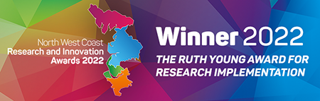
If you want to read more:
https://www.lscft.nhs.uk/news/trust-celebrates-design-mental-health-award-win-1
2. Finalist 2022. Primary Care Initiative of the Year. HSJ Patient Safety Awards 2022. ‘Delivering an Innovative Mental Health Prevention & Promotion service in Primary Care Networks with a new workforce, the ‘Associate Psychological Practitioners’. Winners will be announced on the 15th September.
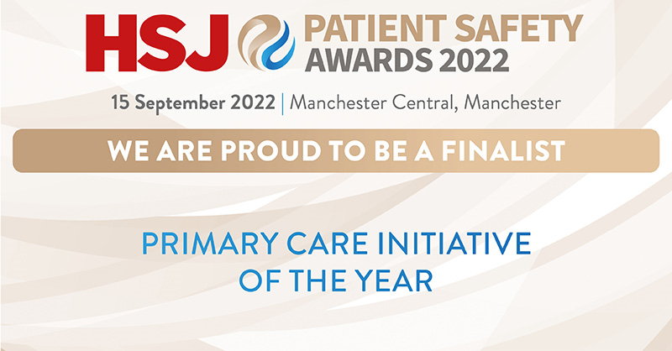

3. Finalist 2022. Primary and Community Care Innovation of the Year. HSJ Awards 2022. ‘Delivering an Innovative Mental Health Prevention & Promotion service in Primary Care Networks with a new workforce, the ‘Associate Psychological Practitioners’. Winners will be announced on 17th November.

