Student Learning and Competency Record

Student Placement



A Tradition of Excellence

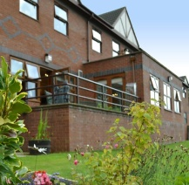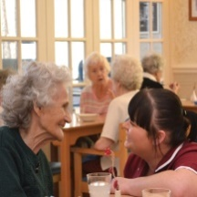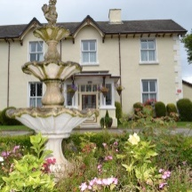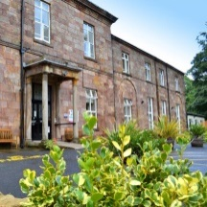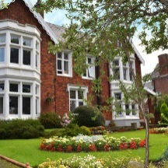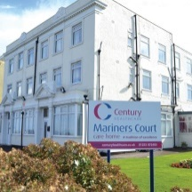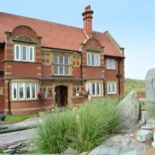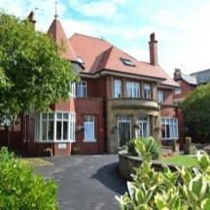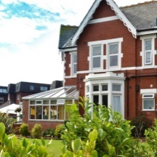

Century Healthcare Ltd. – Learning and Competency Record Student Placements – October 2022

Student’s Name (print):

…………………………………………………………………………………………………………….

Usual Signature:

…………………………………………………………………………………………………………….

Usual Initials:

…………………………………………………………………………………………………………….

Date:

…………………………………………………………………………………………………………….





A Tradition of Excellence

**Welcome to Century Healthcare Ltd.**

**About Century Healthcare**

***A little about us..***

Established in 1998, Century Healthcare is one of the leading providers of care for older people in the North West of England. We offer the very best of care.

Century provides high quality care to every category available including residential, nursing and dementia in our purpose built or converted properties.

All our homes can provide long term, short term, respite or holiday cover breaks and we are happy to accommodate both private and supported clients - everyone receives the same high-class service.

**A few quotes from our residents and relatives:**

“There is no home within a thousand miles that is as good as this.”

"Words like thank you, gratitude and appreciation seem so inadequate but unfortunately these are all we have - but they come straight from our heart...... We don’t know how you managed to get so many loving, caring and dedicated staff under one roof they are all totally amazing every single one of them**."**

**Who’s who?**

**Our Owners**

**Doctor Niraj Brahmabhatt Mr Nikhil Brahmabhatt**

Chair and Nominated person Finance Director

**Head Office Team**

**Mr D Gillies Mrs A. Killip**

Group General Clinical Operations

Manager Manager

* **Tracey Radcliffe** – Team Administrator
* **Lynne Damsell** – Wages
* **Anne Ormerod** – Residents Accounts
* **Rebecca Reeves** – Recruitment Lead

**Our Homes**

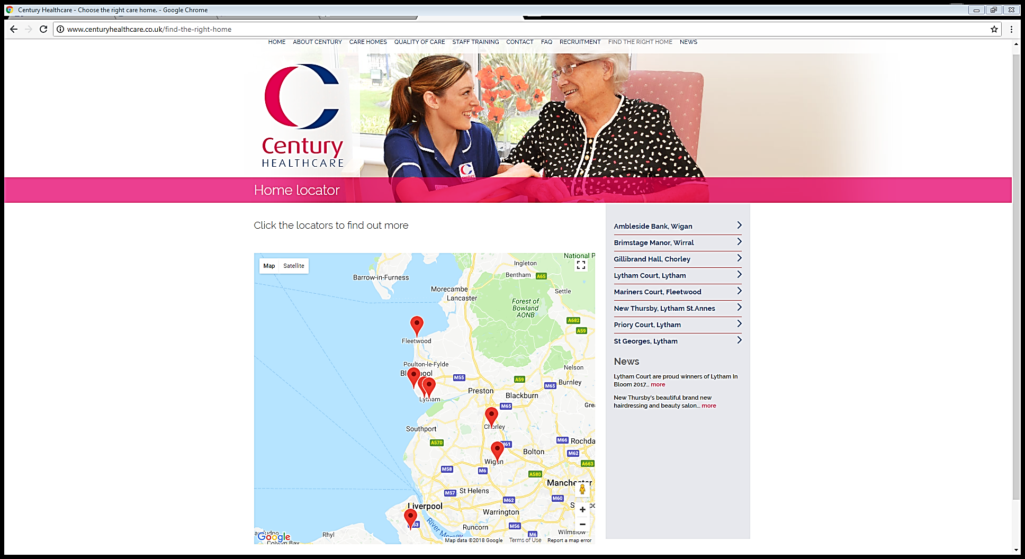

**Our Philosophy**

To provide the highest possible standards of care, within a warm, friendly and dignified environment.

For our residents to live the best life possible.

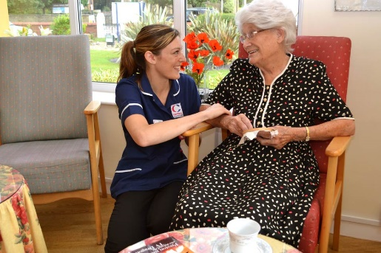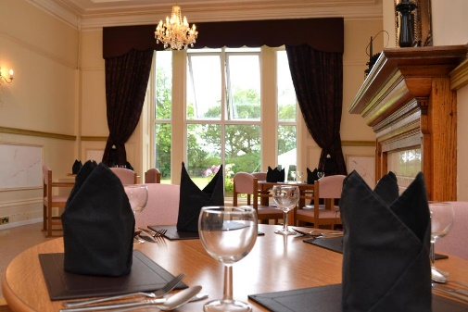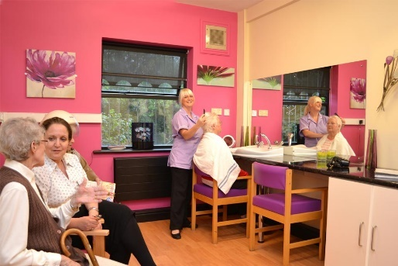

**Placement Induction**

Your induction will include time with an experienced member of staff getting to know our residents, staff, the building and fire procedures.





**Policies & Procedures**



All our policies and procedures are held electronically. Please ask your buddy if you would like to read them. You must not attempt to move or handle any of our residents. Ask a member of staff for assistance.

**Information to help you settle into your new role**

|  |  |
| --- | --- |
| Name of home |  |
| Name of Matron |  |
| Contact Number |  |
| Contact Email |  |
| Name of buddy |  |
| Working days |  |
| Working hours |  |

**The practical bits**

There is a staff room. Please bring lunch with you. A microwave is available as well as tea/coffee making facilities. Tea and coffee are provided free of charge.



If you are sick, please let us know as soon as possible. You must telephone the home and let them know that you will not be in. You must let the home know when you intend to resume your placement.

**Uniform**

Jewellery must be kept to a minimum. A plain metal band and small stud earrings are permissible. No false nails or nail varnish. We operate a ‘Bare Below the Elbows policy’.

We do not permit the wearing of leggings and footwear should be black, low heeled with rubber soles at all times. Sandals, open-toed shoes, flip flops and “crocs” must not be worn.

During your placement please wear something comfortable yet smart.

**Confidentiality**



Any information about our residents’ past or present is strictly confidential. You have a duty of confidence to keep person-identifiable or confidential information private and not to divulge information accidentally.

**You must not reveal any security codes to relatives, visitors or anyone outside of the building.**

**Questions?**





A Tradition of Excellence

**Orientation for Student Placements**

|  |  |  |
| --- | --- | --- |
| **1.** | **Orientation of building to include:** | Tick & Sign on completion |
| a | Location of Offices. |  |
| b | Location of Treatment Room. |  |
| c | Location of Emergency & First Aid Equipment. |  |
| d | Location of Accident book |  |
| e | Laundry. |  |
| f | Kitchen. |  |
| g | Staff Room, Toilets etc. |  |
| h | Nurse Call System. |  |
| i | Code numbers for door keypads. |  |
| **2.** | **Residents** | |
| a | Current Occupied Rooms. |  |
| b | Location of Service Users Daily Reports and Care Files. |  |
| **On completion, the trainer and student are to sign the Day 1 Induction form.** | | |

|  |  |  |
| --- | --- | --- |
| **Student** | Signature: | Date: |
| **Inductor** | Signature: | Date: |



A Tradition of Excellence

**Fire Induction Checklist**

|  |
| --- |
| **All students must receive this initial training as part of their Day One Induction.** |
| **1.** Orientation of the building  **2.** Emergency Exits and Fire Escapes *(include kitchen window at Lytham Court only)*  **3.** Differences between Heat and Smoke Detectors  **4.** Emergency Lighting  **5.** Fire Extinguishers and Signage  **6.** Fire Doors, Closers, Stops – **“ALL DOORS TO BE CLOSED AFTER 11PM”**  **7.** Keypads and codes – doors open an alarm sounding  **8.** Fire Panel  **9.** Fire Zone Maps  **10.** Fire Instructions displayed at the fire panel  **11.** Assembly and Evacuation Points  **12.** Evacuation procedure – horizontal evacuation behind **TWO** fire doors  **13.** Break Glass  **14.** Reporting incidents |
| **On completion, the trainer and student are to sign the Day 1 Induction form.** |

|  |  |  |
| --- | --- | --- |
| **Student** | Signature: | Date: |
| **Inductor** | Signature: | Date: |



A Tradition of Excellence

**Day One Induction**

|  |  |  |  |  |
| --- | --- | --- | --- | --- |
| **Details** | **Person Responsible** | **Signed**  **Inductor** | **Signed**  **Inductee** | **Date** |
| Student learning and competency record issued | Manager/  Administrator |  |  |  |
| Discussion about placement activities | Buddy |  |  |  |
| Placement days and hours agreed | Manager/ Buddy |  |  |  |
| Orientation of the Building completed  (including Safety & Security) | Manager/ Buddy |  |  |  |
| Fire Induction completed | Manager/ Buddy |  |  |  |
| Confidentiality discussed | Manager/ Buddy |  |  |  |
| Safety & Security discussed  (when completing Orientation) | Manager/ Buddy |  |  |  |
| Whistleblowing discussed | Manager/ Buddy |  |  |  |
| Staff Personal Hygiene & Dress Code discussed | Manager/ Buddy |  |  |  |
| Assigned Buddy as necessary | Manager/ Buddy |  |  |  |
| Assign Student Activity/Competency Record | Manager/ Buddy |  |  |  |

Notes:



A Tradition of Excellence

**Safeguarding Children**

**Aims;**

* Know What to do if you suspect or are Worried a Child is being Abused
* Be Aware of our Duty to Promote and Safeguard Children.
* Know Where to Seek Further Help and Advice

**Why?**

* Duty within the workplace to safeguard and promote children's and young peoples’ welfare.*A child is anyone who has not yet reached their 18th birthday.*

(Ref. Children Act 1989 and 2004)

**Abuse & Neglect Definition;**

* Abuse and neglect are forms of maltreatment of a child. Somebody may abuse or neglect a child by inflicting harm, or by failing to act to prevent harm
* Children may be abused in the family or in an institutional or a community setting, by those known to them or, more rarely, by others e.g. via the internet). They may be abused by an adult or adults, or another child or children.

(Ref. Working Together 2015 - Glossary)

**Who are Children likely to turn to?**

* Friends
* Mothers
* Fathers
* Other trusted adults

‘No matter where you work, you are likely to encounter children during the course of your normal working activities. You are in a unique position to be

able to observe signs of abuse or neglect, or changes in behaviour which may indicate a child may be being abused or neglected’ That is why safeguarding is everyone’s responsibility:

**Categories of Abuse;**

* **Physical**
* **Emotional/Psychological**
* **Sexual**
* **Neglect**

Common sites for Accidental Injury

Forehead

**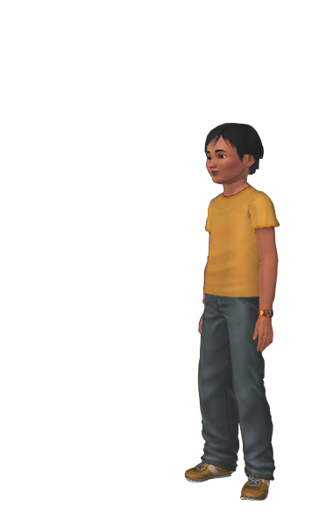**

Nose

Bony spine

Chin

Elbows

Forearm

Knees

Hips

Shins

Common sites for Non- Accidental Injury

**Scull** – fracture, bruising, or bleeding under the scull from shaking

**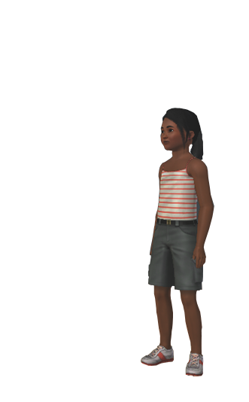**

**Cheek/Side of Face** – bruising,

finger marks

**Eyes** – bruising, black,

particularly both eyes

**Mouth** – torn frenulum

**Ears** – pinch or slap marks

**Chest** – bruising, grasp marks

**Shoulders** – bruising, grasp marks

**Genitals** – bruising

**Upper & Inner Arms** – bruising,

grasp marks

**Knees** – grasp marks

**Back**

****

**Buttocks**

**Thighs**

Linear bruising, outline of belt/buckle, scald/burn

**BD05427_Sharing Information;**

* Keeping children safe from harm requires

professionals and others to share

information.

* In many cases it is only when information

from a range of sources is put together

that a child can be seen to be in need or

at risk of harm.

**Don’t think “What if I’m wrong?”, think “What if I’m right?”**

**Who do you share information with?**

* It is your responsibility to share your concerns with your safeguarding lead/Matron/Manager.
* Take the appropriate action. They may or may not keep you informed of progress as child protection information is shared on a need to know basis.

|  |  |  |
| --- | --- | --- |
| **Student** | Signature: | Date: |
| **Inductor** | Signature: | Date: |



A Tradition of Excellence

**Mental Capacity Act (MCA) 2005**

**What does the Act aim to do?**

* Provide empowerment - for adults who may lack capacity enabling them to maximise their autonomy.
* Provide protection - for adults who lack capacity and for those who care for them.
* Provide choice - by allowing people to appoint those they trust to take decisions for them if they should lose capacity.

**How does the Act do this?**

* The Act sets out a framework for those who lack capacity.
* It is accompanied by a Code of Practice.

**The Act:**

* Sets out a number of key principles.
* Creates new decision making mechanisms.
* Establishes new bodies to support the framework.
* Creates a new criminal offence.

**The 5 Key Principles**

* Assume a person has capacity unless proved otherwise.
* Do not treat people as incapable of making a decision unless you have tried all practicable steps to help them.
* Do not treat someone as incapable of making a decision because their decisions seem - to you – unwise.
* Do things, and take decisions for, people without capacity in their best interests.
* Before doing something to someone or making a decision on their behalf, consider whether you could achieve the outcome in a less restrictive way.

**Determining Capacity**

* Act sets out assumption of capacity.
* There is an obligation to take “all practicable steps” to help the person make his or her own decision.

**Best Interest Decisions**

* All decisions must be made in the best interests of the person concerned.
* Statutory guidance on how best interests are determined.
* Must consider all relevant circumstances.

**Checklist approach**

* Obligation to have regard for ‘past and present wishes and feelings’
* Consult with others who are involved with the care of the person
* Least restrictive decision.

**Acts in connection with Care or Treatment**

* Legal principle: no-one can interfere with another adult’s body or property unless the adult consents.
* The Act provides a defence against liability for people who need to do things to someone who lacks capacity to consent, ***so long as they are acting in the person’s best interests.***
* The clause enables carers or professionals to lawfully help persons who cannot consent.
* It sets boundaries for when and how they can act.

**The new Decision-Making Mechanisms**

* Lasting Power of Attorney.
* Court Appointed Deputies.
* Advance Decisions to Refuse Treatment.

**Lasting Power of Attorney (LPA)**

* Enable you to appoint someone of your choice to make decisions on your behalf.
* Can cover all areas - financial or welfare (including healthcare).
* Must be made whilst you have capacity.
* Attorney can make decision on your behalf if in your best interests.

**Court Appointed Deputy**

* Could be used when a series of decisions are needed and a single order from the court is insufficient.
* Deputy will always be given the minimum powers necessary.
* Checks to get the right person appointed.
* Must allow person without capacity to make what decisions they can.

**Advanced Decision to Refuse Treatment**

* Made by a person with capacity setting out what treatment would be unacceptable to them and in what circumstances.
* Must be valid and applicable to the situation.
* Doctors need to be satisfied that it still applies.
* Only comes into effect once a person has lost capacity.

|  |  |  |
| --- | --- | --- |
| **Student** | Signature: | Date: |
| **Inductor** | Signature: | Date: |



A Tradition of Excellence

**Deprivation of Liberty Safeguards (DoLS)**

**Article 5 of the European Convention on Human Rights Act** states: "Everyone has the right to liberty and security of person” and “No one shall be deprived of his or her liberty **(unless)** in accordance with a procedure prescribed in law”.

**The Mental Capacity Act (2005**) outlines how an individual can be deprived of their liberty in order to care for them safely, and **Deprivation of Liberty Safeguards** (or DoLS) are one such procedure prescribed in law that is invoked to protect the peoples and ensure their loss of liberty is lawful. Care should always be provided in the least restrictive way possible, and those responsible for providing care should explore all options.

DoLS are an amendment to the Mental Capacity Act 2005 that applies in England and Wales and can only be applied in a care home or hospital setting.

An individual is deprived of their liberty for the purposes of Article 5 of the European Convention on Human Rights if they:

* Lack the capacity to consent to their care/treatment arrangements.
* Are under continuous supervision and control.
* Are not free to leave.

**Criteria to Authorise DoLS**

There are **six criteria** that needs to be assessed before DoLS can be authorised by the local authority:

* Is the individual aged 18 years or above as required?
* Does the individual have a mental health disorder (this includes dementia)?
* Does the individual have the capacity to make their own decisions regarding treatment?
* Is the use of DoLS in the individual’s best interest? Namely, will it keep them safe from harm?
* Does the individual meet the requirements for detention under the Mental Health Act 1983? (This would make them ineligible for a standard authorisation).
* Has the individual made any advanced decisions about their treatment? Is there any previous authorisation that would conflict with the authorisation of DoLS?

If authorisation is given, one key safeguard is a person is appointed with legal powers to represent the individual, called a **Relevant Persons Representative** (RPR) – this will usually be a family member, friend or **Independent Mental Capacity Advocate** (IMCA). Another important safeguard is access to Independent Mental Capacity Advocates, particularly if there are no family or friends willing or available to act as an RPR.

**Who is affected by DoLS?**

DoLS can only apply to people who are in a care home or hospital and if authorised, it can last for up to one year but restrictions can stop as soon as they are no longer required. If an individual is living in another setting, it is still possible to deprive the person of their liberty in their best interests but DoLS cannot be applied; this is usually done through an application to the Court of Protection.

|  |  |  |
| --- | --- | --- |
| **Student** | Signature: | Date: |
| **Inductor** | Signature: | Date: |



A Tradition of Excellence

# **Prevent**

**Radicalisation** is the process that moves a person to legitimise their support or use of violence. It is where terrorism begins.

Terrorism isn’t just the attack this is just the tip of the iceberg. It is the hidden activity that leads to the attack.

**Behaviours that cause concern:**

**Outward appearance:**

* Becoming increasingly argumentative.
* Refusing to listen to different points of view.
* Unwilling to engage with students who are different.
* Becoming abusive to students who are different.
* Embracing conspiracy theories.
* Feeling persecuted.
* Changing friends and appearance.
* Distancing themselves from old friends.
* No longer doing things they used to enjoy.
* Converting to a new religion.
* Being secretive and reluctant to discuss their whereabouts.
* Sympathetic to extremist ideologies and groups.

**Online behaviour:**

* Changing online identity.
* Having more than one online identity.
* Spending a lot of time online or on the phone.
* Accessing extremist online content.
* Joining or trying to join an extremist organisation.

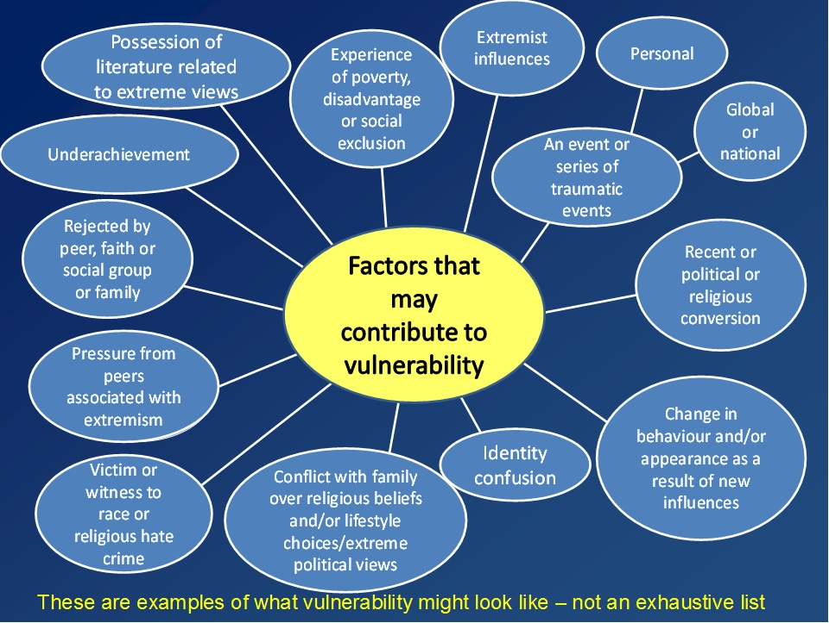

**Prevent** is a vital part of the UK’s counter-terrorism strategy, to stop people becoming terrorists or supporting terrorism. It seeks to:

* Respond to the ideological challenge of terrorism and aspects of extremism, and the threat we face from those who promote these views.
* Provide practical help to prevent people from being drawn into terrorism and ensure they are given appropriate advice and support.

Work with a wide range of sectors where there are risks of radicalisation and a multi-agency approach is needed including education, criminal justice, faith, charities, the internet and health.

**Prevent** addresses all forms of terrorism, including Far Right extremism and some aspects of non-violent extremism. Work is conducted with the Police, Local Authorities, Government Departments and health services.

**Channel** is a Multi-Agency process within **Prevent**, which aims to support those who may be vulnerable to being drawn into violent extremism. It works by Identifying individuals who may be at risk, assessing the nature and extent of the risk; and where necessary, referring cases to a multi-agency panel which decides on the most appropriate support package to divert and support the individual at risk.

The key challenge is to be vigilant for signs that someone has been or is being drawn into terrorism. Examples of concerns could be overhearing a staff member’s conversation, or a service user being encouraged to finance this type of activity. The care home **Safeguarding/Prevent Lead** will advise and signpost in raising concerns following the referral pathway in line with the policy and procedure.

**It is important to note that Prevent operates within the Pre-Criminal Space and is aligned to the Multi-Agency Safeguarding Agenda.**

**NOTICE** – if you have a cause for concern about someone, perhaps their altered attitude or change in behaviour.

**CHECK -** discuss concern with appropriate other (Safeguarding Lead/Matron/Manager).

**SHARE** – appropriate, proportionate information (Safeguarding Lead/Police).

[Further information](http://www.lancashire.police.uk/help-advice/safer-communities/counter-terrorism/policy-and-strategy.aspx) can be found on the following website and from Lancashire Constabulary, Merseyside Constabulary and Greater Manchester Police.

<https://www.gov.uk/government/publications/prevent-duty-guidance/revised-prevent-duty-guidance-for-england-and-wales>

|  |  |  |
| --- | --- | --- |
| **Student** | Signature: | Date: |
| **Inductor** | Signature: | Date: |



A Tradition of Excellence

**Hand Hygiene Audit**

Audit completed by: …………………………………………………..…………………. Date: …………….…….………………….

|  |  |  |
| --- | --- | --- |
| **Criteria – All criteria are essential** | | |
| **Hand washing** | | |
| **Hand Preparation** | **Achieved** | **Not Achieved** |
| Hands and wrists are free from watches and jewellery  (non-stoned wedding rings are acceptable) |  |  |
| Nails are short and without nail extensions and varnish |  |  |
| Sleeves are short or rolled up during hand washing |  |  |
| Cuts are covered with a waterproof dressing |  |  |
| **Hand washing technique** |  |  |
| Hands are wet under continuously running water |  |  |
| Warm Water is used to wash hands |  |  |
| Dispensed liquid soap is used |  |  |
| Liquid soap is applied to wet hands |  |  |
| Hands are rubbed to create a lather |  |  |
| The lather is rubbed over all surfaces of the hands for **10-15 seconds**, including the thumbs, between the fingers, fingertips and the wrist |  |  |
| Hand are rinsed thoroughly under running water |  |  |
| **Drying of Hands** |  |  |
| Hands are dried using paper towels |  |  |
| **Alternative** |  |  |
| **Hand Hygiene using Alcohol based hand rubs** |  |  |
| **Hand Preparation** |  |  |
| Hands and wrists are free from watches and jewellery  (non-stoned wedding rings are acceptable) |  |  |
| Nails are short and without nail extensions and varnish |  |  |
| Sleeves are short or rolled up during hand hygiene |  |  |
| Cuts are covered with a waterproof dressing |  |  |
| Hands are visibly clean |  |  |
| Alcohol based hand rub is dispensed onto the hands |  |  |
| Alcohol hand rub is rubbed onto the hands ensuring all surfaces are covered by the alcohol |  |  |
| Hands are rubbed until the alcohol has evaporated |  |  |

**Action Plan**

|  |  |  |
| --- | --- | --- |
| **Required Action** | **To be completed by** | **Date Re-audit to be carried out** |
|  |  |  |



A Tradition of Excellence

**Student Activity and Competency Records**

**Start Date: …………………………………………………………………..**

**Name -**

This record is to support and evidence your learning for the duration of your placement.

Signing off an activity should only be completed when the student has demonstrated that they understand the requirement of the activity and have demonstrated that their practice is safe.

|  |  |  |  |
| --- | --- | --- | --- |
| **Area of Activity** | **Is the Student able to discuss and demonstrate Safe Practice?**  **YES/NO** | **Signature**  **of**  **Student** | **Signature**  **of**  **Buddy** |
| **Supporting Residents** | | | |
| Brushing and combing hair |  |  |  |
| Cleaning glasses |  |  |  |
| Applying and removing nail varnish |  |  |  |
| Applying make up |  |  |  |
| Able to discuss and demonstrate how privacy and dignity is promoted |  |  |  |
| **Communication** | | | |
| Able to chat and socialise with residents |  |  |  |
| Reporting and writing what activities they have completed with individual residents |  |  |  |

|  |  |  |  |
| --- | --- | --- | --- |
| **Health & Safety** |  | | |
| Able to report spills appropriately |  |  |  |
| Able to report faults appropriately |  |  |  |
| Know how to use nurse call bell |  |  |  |
| Awareness of infection control measures |  |  |  |
| Understanding of emergency fire drill procedure |  |  |  |
| Knows who to report to if feeling unwell |  |  |  |
| **Waste Management** |  | | |
| General waste disposal |  |  |  |

# 

|  |  |  |
| --- | --- | --- |
| **Student** | Signature: | Date: |
| **Inductor** | Signature: | Date: |

# Once complete, please send a copy of this page to Head Office.

# **Use this section to record what activity you have undertaken and any learning from this activity.**

# **Date**

|  |  |  |
| --- | --- | --- |
| **What did I do today** | **What did I learn** | **If I did this again, would I change anything?** |
| **Buddy’s comments -** | | |

# **Date**

|  |  |  |
| --- | --- | --- |
| **What did I do today** | **What did I learn** | **If I did this again, would I change anything?** |
| **Buddy’s comments -** | | |

# **Date**

|  |  |  |
| --- | --- | --- |
| **What did I do today** | **What did I learn** | **If I did this again, would I change anything?** |
| **Buddy’s comments -** | | |

# **Date**

|  |  |  |
| --- | --- | --- |
| **What did I do today** | **What did I learn** | **If I did this again, would I change anything?** |
| **Buddy’s comments -** | | |

# **Date**

|  |  |  |
| --- | --- | --- |
| **What did I do today** | **What did I learn** | **If I did this again, would I change anything?** |
| **Buddy’s comments -** | | |

# **Date**

|  |  |  |
| --- | --- | --- |
| **What did I do today** | **What did I learn** | **If I did this again, would I change anything?** |
| **Buddy’s comments -** | | |



A Tradition of Excellence

# **Summary of placement.**

To be completed with the student on their last placement day.

|  |  |  |  |  |
| --- | --- | --- | --- | --- |
| **Area** | **Excellent** | **Good** | **Poor** | **Comments** |
| Punctuality |  |  |  |  |
| Appearance |  |  |  |  |
| Attitude |  |  |  |  |
| Enthusiasm |  |  |  |  |
| Verbal communication |  |  |  |  |
| Record keeping |  |  |  |  |
| Adherence to infection control requirements |  |  |  |  |
| Able to follow instructions |  |  |  |  |
| Resident feedback |  |  |  |  |
| Staff feedback |  |  |  |  |

|  |  |  |
| --- | --- | --- |
| **Student** | Signature: | Date: |
| **Inductor** | Signature: | Date: |