From: Richard Williams <Richard.Williams@edgehill.ac.uk>
Sent: 29 April 2024 16:10
Subject: Scoping of interest - 18 month NA to RN top up programme

Dear Practice Partners,

Apologises for sending out yet another email into your mailboxes but, as some of you may be aware we are currently considering the development of a new 18 month ‘top up’ to Registered Nurse programme. Some of you may have already had discussions with members of our apprenticeship programmes.

For us to progress with this development we need to seek approval from the University and part of that process is gathering intelligence in relation to its viability as a programme. For ease, I have created a short Microsoft Forms to capture very basic, noncommittal, information from yourselves. This information will be used to help us build a case for approval.

Link to form: https://forms.office.com/e/gzh3eA90b3 - if you could complete this at your earliest convenience this would be greatly appreciated.

If you have received this and are not the correct person then please forward on to the most relevant person to complete.

Hopefully, you can support and thank you in advance for taking the time to complete the form.

Many Thanks

Richard Williams (he/him)  Head of Practice Education and Apprenticeships  School of Nursing and Midwifery Education  T: 0151 529 6075 Ext (6075)  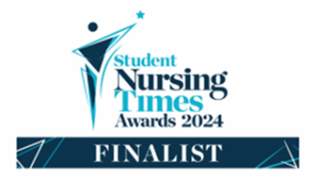  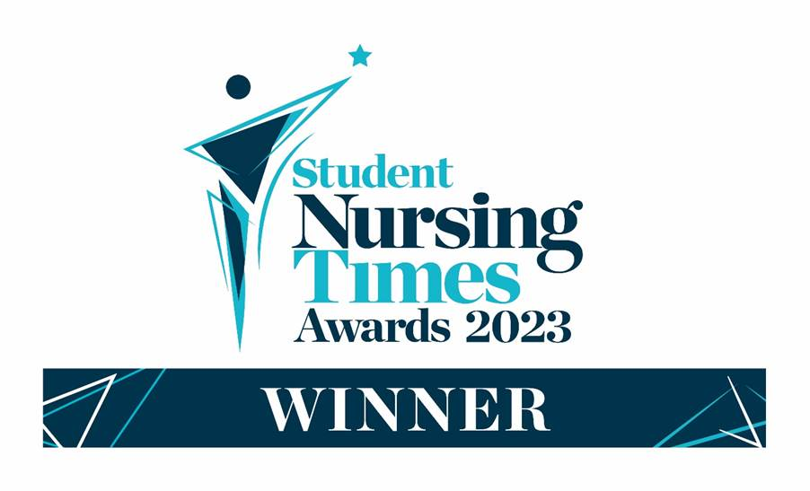 | Edge Hill University  University Hospital Aintree  Longmoor Lane, Liverpool, L9 7LN  Please note that if I am cc’d on an email, I will assume this is for informational purposes only and no action is required on my part.  Advance Notice of Leave

https://www.england.nhs.uk/publication/safe-learning-environment-charter-what-good-looks-like/

Edge Hill University
Modern University of the Year, The Times and Sunday Times Good University Guide 2022
University of the Year, Educate North 2021/21

